Title: **Analysing Adaptive Responses of Smallholder Black Pepper Farmers in Kerala: A Choice Modelling Approach to Climate Change-Relevant Decisions.**

1. **Introduction**

Black Pepper, revered as "Black Gold," stands as an iconic spice in global trade, with its origins deeply rooted in the lush landscapes of Kerala, a South Indian state renowned for its spice cultivation. Contributing significantly to India's agricultural landscape, black pepper holds a prominent position, with major cultivation hubs in Karnataka, Kerala, and Tamil Nadu. Despite its historical significance and economic importance, the black pepper industry faces multifaceted challenges stemming from climatic variability, environmental stressors, and economic volatility.

The production dynamics of black pepper in Kerala reflect the intricate interplay between natural phenomena and agricultural practices. Notably, the state experienced a tumultuous period marked by devastating floods in 2018 and 2019, leaving enduring impacts on soil quality and fertility (Figure 1). Studies conducted post-flood underscored a discernible decrease in essential soil nutrients, complicating the agricultural landscape. Furthermore, climatic anomalies, such as erratic rainfall patterns and rising temperatures, have emerged as pivotal factors influencing black pepper cultivation. The delayed onset of the southeast monsoon disrupts critical phases of the plant's growth cycle, including flower initiation, ultimately hampering yield outcomes. Moreover, the reduction in post-blossom rain adversely affects pollination and berry development, exacerbating production challenges. Beyond local environmental factors, the global black pepper market grapples with pronounced price volatility, aggravated by economic variables like currency fluctuations, labour expenses, and weather-induced crop yield variations. Smallholder farmers, constituting a significant proportion of producers, bear the brunt of these fluctuations, particularly in less developed countries across Africa and Asia, where climate change impacts are disproportionately severe.

Against this backdrop, this paper aims to explore the intricate nexus between climatic variability, environmental stressors, and agricultural practices, with a specific focus on black pepper production in Kerala, India, a state renowned for its black pepper production. By elucidating the multifaceted challenges confronting the industry, this study attempts to provide insights that inform resilient agricultural strategies and mitigate the adverse effects of climate change on black pepper cultivation.

In response to the escalating challenges posed by climate change, the imperative for farmers to adapt their practices has never been more pressing. Acknowledging the pivotal role of adaptation in ensuring sustainable agricultural yields, the term "Climate Change-Relevant Decisions" (CCRDs) was coined, which encompass actions contributing to both mitigation and adaptation efforts. These decisions are framed within cognitive theories, emphasizing the cognitive processes that underpin farmers' adaptation strategies.

The adaptive responses of individuals to climate change are multifaceted and influenced by a plethora of interdisciplinary theories spanning anthropology, geography, cognitive science, political science, psychology, rural sociology, economics, and data science. Through empirical research, these theories have been extended and refined, providing valuable insights into human decision-making in the context of climate change.

Understanding the decision-making patterns and preferences of farmers is crucial for designing effective interventions and strategies tailored to their specific needs. By aligning adaptation practices with farmers' cognitive frameworks, interventions can enhance their ability to cope with challenges and bolster their resilience. These efforts typically encompass a blend of psychological support, skill-building initiatives, and the creation of supportive environments conducive to adaptation.

In this study, we delve into the adaptation strategies employed by smallholder black pepper farmers in the major cultivation regions of Kerala, India. Specifically, we address two interconnected sub-questions: (1) What adaptation strategies do smallholder farmers in these regions typically employ in response to climate change? (2) Which adaptation practices do farmers prioritize to ensure sustained income from their plantations?

In this study, we utilize Best-Worst Scaling (BWS) as a method to analyse the adaptive responses of smallholder black pepper farmers in Kerala to the challenges posed by climate change. BWS is a powerful technique that allows us to explore farmers' preferences by asking them to identify both the best and worst options within a set of adaptation strategies. This approach offers several advantages, including capturing the relative importance farmers assign to different strategies, reducing response bias by forcing respondents to make trade-offs, and creating a decision context that mirrors real-world scenarios.

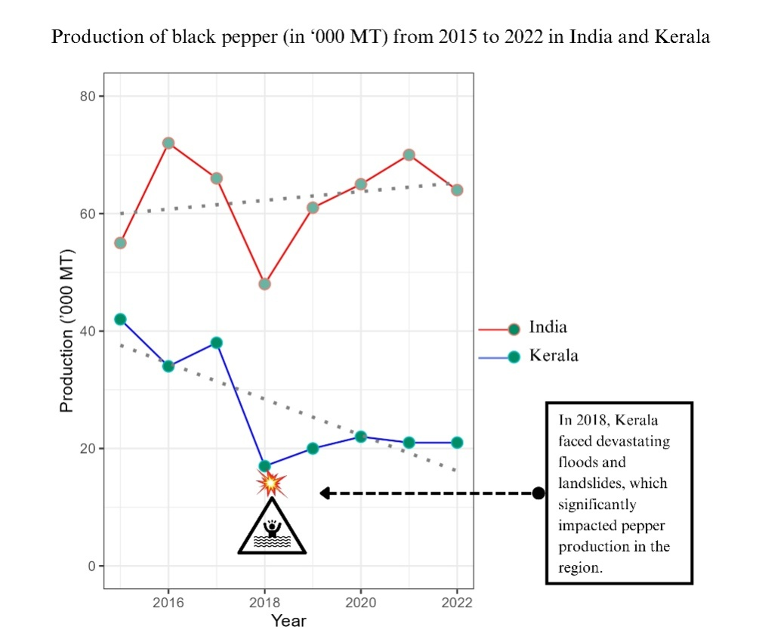

Figure 1 Production of black pepper from 2015 to 2022 in India and Kerala

**2. Materials and Methods**

2.1 Study area

The selection of study areas was based on the consideration of multiple factors, primarily focusing on the significance of districts in Kerala's black pepper production landscape. Among the 14 administrative districts in Kerala, Idukki and Wayanad were identified as focal points due to their exceptional prominence in black pepper cultivation. In the 2019-20 period, Idukki (Southern hills) stood out with a sprawling area of 42,822 hectares dedicated to black pepper cultivation, yielding a production of 20,560 tons, and achieving a productivity rate of 480 kg/ha, where national and state productivity was 235.39 and 239 kg/ha respectively. Similarly, Wayanad (Northern hills) exhibited substantial figures, with 10,307 hectares under pepper cultivation, resulting in a production of 3,694 tons and a productivity rate of 358 kg/ha. These districts not only lead the state in terms of area, production, and productivity but also contribute significantly to the state's overall pepper output, with Idukki alone accounting for as much as 59.52% of the total production. Their significant contributions to the overall state production, as well as their diverse geographical and socio-economic characteristics, make them ideal subjects for comprehensive analysis. Moreover, the unique agricultural practices, environmental conditions, and socio-economic factors prevalent in these districts offer valuable insights into the dynamics of black pepper cultivation in the light of climate resilience, thereby justifying their selection as primary areas of focus in the study.

The Kerala state is divided into 23 agro-ecological units (AEUs) depending upon various factors such as topography, soil types, climate patterns, and vegetation cover. These AEUs acknowledges the heterogeneity of Kerala's terrain and the importance of considering local environmental conditions in agricultural decision-making. The five AEUs having higher area of cultivation under black pepper were purposively selected from the Idukki (3 AEUs) and Wayanad (2 AEUs) districts. Areasfrom these AEUs were selected purposively depending upon the prevalence of climate change related events as reported by the agricultural office (*Krishibhavan*), during the preliminary survey. The small holder farmers who possess land holding up to 5 acres were randomly selected from the list obtained from the *Krishibhavans*.

The survey was conducted during the period 2022-23 and 2023-24. The best-worst scaling of climate change adaptation alternatives together with the data on socio-economic profile, cost of cultivation, yield and returns from cultivation were collected from 198 smallholder farmers of which 150 farmers provided valid responses. Therefore, the effective sample size became 150.

Their significant contributions of these areas to the overall state production, as well as their diverse geographical and socio-economic characteristics, make them ideal subjects for comprehensive analysis. Moreover, the unique agricultural practices, environmental conditions, and socio-economic factors prevalent in these districts offer valuable insights into the dynamics of black pepper cultivation in the light of climate resilience, thereby justifying their selection as primary areas of focus in the study.

Theoretical framework

External and internal limits on bounded rationality constrain the climate-related preferences and motives of decision-makers in smallholder farming systems Simon, 1955 ((Fiori, 2011; Waldman et al., 2021).

“Understanding how and why people make particular CCRDs requires moving

beyond traditional rational-actor models of human behavior through the incorporation of more sophisticated and nuanced mechanisms, and the recognition of specific factors at the level of individuals and organizations” (Climate Decision-Making | Annual Reviews, n.d.)

Factors such asemotions, social, intertemporal discounting, incomplete information search and processing, experiential learning, and rapid decision-making processes (e.g., status quo bias, anchoring, loss aversion(van Valkengoed& Steg, 2019) put limits on rationality. Behavioural spillover, interpersonal spillover, and decision pathways are three phenomena that influence sequential and mutually linked decisions regarding climate change. (Climate Decision-Making | Annual Reviews, n.d.).

Heuristics and biases play a significant role in decision-making processes, as individuals often rely on mental shortcuts to simplify complex choices.(Tversky & Kahneman, 1974)

Human decision-makers routinely ignore their own, fully conscious, preferences inmaking decisions. They follow rules, traditions, hunches, and the advice or actions of others. (March, 1978). Inconsistency in preferences leads to reversal of the perspectives and humans follow a coherent course of action to make a final decision. (Fiori, 2011).

Actions and decisions are made automatically, following established patterns rooted in tacit knowledge. This phenomenon of developing ‘organisational routines’ as described by Nelson and Winter (1978) and Fiori (2011) also shapes the preferences of decision-makers.

The temporal limits on CCRDs demandquick adaptive responses from decision-makers using simple fast and frugal heuristics.

A computationally simple strategy that uses only some of theavailable information can be more robust, making more accurate predictions for new data, than a computationally complex, information-guzzling strategythat overfits’ (Gigerenzer& Todd, 1999, p. 20).

The choice modeling approach followed in this study matches with the structure of information search in the naturaldecision environment that is bounded bythe motivation, tacit knowledge, inconsistent preferences, and goals of the decision-makers.

In this study, while we acknowledge the compounding influence of poverty and climate change on decision-making processes, it's imperative to note that we did not undertake an assessment of the incurred costs associated with individual adaptation practices and assume that this is reflected in the selection of relevant profiles by respondent farmers.

2.2 Attribute and level selection

Attributes and attribute level selection for the study involved a collaborative effort between researchers and subject matter experts, aiming to capture the decision-making processes of smallholder farmers regarding climate resilience strategies in the southern and northern hills of Kerala. Initially, pilot surveysusing online survey tools and personal interviews were conducted to identify relevant attributesin this context. These attributes represent key factors or characteristics that farmers consider when making decisions related to climate resilience.The variability in the attribute “cropping systems’ inthe focal points of data collection, Idukki and Wayanad was considered while defining the attribute levels associated. Migration from central Kerala to both regions has historically facilitated uniform knowledge transfer, resulting in comparable attribute levels across various domains.

Following the pilot surveys, subject matter experts from the Indian Institute of Spices Research (IISR) and the Central Marine Fisheries Research Institute (CMFRI), in conjunction with agricultural extension scientists from the Central Research Station (CRS) in Pamapadumpara and regional stations under Kerala Agriculture University, validated the identified attributes. This validation process ensured that the selected attributes accurately reflected the real field conditions and considerations pertinent to smallholder farmers in the region.

Most of the adaptation measures refer to alternative activities that aim to generate income. (Biggs et al., 2013)(Habtemariam et al., 2020) (Biggs et al., 2013). Adaptation strategies adopted largely build upon traditional practices, or in some cases are guided by government policy.(Biggs et al., 2013).

Finalized set of attributes which include (A) organic farming practices, (B) grafting for stress tolerance, (C) use of landraces, and (D) cropping systems were selected. Each attribute is further delineated into specific attribute levels. The attribute levels for attribute A are denoted as A1, A2, and A3, while for attribute B, they are denoted as B1, B2, B3, and so forth., which represent different conditions or characteristics within that attribute given in Table 1. These attribute levels were selected based on their relevance to real field conditions in the study regions.

|  |  |  |
| --- | --- | --- |
| Attribute | Definition | Attribute levels |
| 1. Organic farming | Compliance with organic agriculture | (A1) A combination of chemical and organic methods proves more effective for adapting to climate change |
| (A2) Exclusively employing organic inputs in crop cultivation aids in adapting and mitigating climate change-associated management issues. |
| (A3) Certified organic farming serves as an adaptation and mitigation strategy. |
| 1. Grafting for stress tolerance | Grafting with *Pipercolubrinum*as rootstock on pepper *to* increase biotic and abiotic stress tolerance | (B1) Grafting is not effective in the long run |
| (B2) Production and sale of bush pepper plants having ornamental and culinary value grafted on *Piper colubrinum* for home gardens. |
| (B3) Raising grafted plants with irrigation in the main field increases abiotic and biotic stress tolerance. |
| 1. Landraces | Varietal diversity | (C1) One or two high-yielding varieties/ landraces |
| (C2) More than two high-yielding varieties/ landraces |
| (C3) More than two high-yielding varieties along with selected landraces known for climate resilience |
| 1. Cropping system | Number, type, and tiers of crops | (D1) Sole crop |
| (D2) Two-tiered diversified cropping system with coffee /cocoa /tree spices/areca nut / coconut |
| (D3) Three-tiered diversified cropping system with cardamom and tree spices/Arecanut and Coconut |

Table 1 Selected Attributes and Attribute Levels for Climate Resilience Strategies in smallholder farmers' decision-making in pepper cultivation

2.3 Best Worst Scaling

Best Worst Scaling (BWS) is a survey methodology used for evaluating preferences by asking respondents to select the best and worst items from a set of alternatives. It is particularly useful for capturing relative importance and preferences among multiple options. BWS has been described as "a method for capturing preference data in which respondents make a series of choices among subsets of items" (Louviere *et al*., 2015). This approach allows to elicit context-specific insights into decision-making processes.

BWS (Best Worst Scaling) was selected as the methodology in this study due to its unique advantages in evaluating preferences and priorities. BWS allows for the systematic comparison of items within a set, enabling respondents to indicate both the best and worst options, thereby providing richer and more nuanced data than traditional ranking methods. This methodology is particularly well-suited for our study, as it allows us to capture the relative importance and preferences of various factors influencing decision-making in black pepper cultivation. Its ability to quantify both positive and negative evaluations provides deeper insights into the factors driving decision-making.

In addition to its methodological advantages, we selected Best Worst Scaling (BWS) for its ease of implementation and ability to mitigate respondent confusion when ranking multiple profiles. BWS surveys are relatively straightforward for participants to complete, as they involve simply selecting the best and worst options from a set of alternatives, rather than assigning numerical rankings. This simplicity reduces respondent burden and minimizes the likelihood of survey fatigue or dropout, ensuring higher response rates and more reliable data. Moreover, by focusing respondents' attention on identifying the best and worst options within a given set, BWS reduces cognitive load and avoids the potential for confusion that can arise when attempting to rank multiple profiles according to complex criteria.

2.4 Profile creation

A 34 orthogonal array (OA) with four factors generated was utilized to systematically create profiles representing various combinations of factor levels for the attributes (A) organic farming practices, (B) grafting for stress tolerance, (C) use of landraces, and (D) cropping systems. Each profile in the OA corresponds to a unique combination of factor levels for these attributes, enabling structured experimentation and analysis. The utilization of orthogonal arrays (OAs) in profile creation offers several significant advantages. Firstly, by employing OAs, we can explore a diverse range of factor combinations related to attributes. This systematic exploration allows you to efficiently cover a large experimental space while minimizing the number of profiles employed in the study. In addition, OAs ensure a balanced distribution of factor combinations, which is crucial for ensuring that each attribute and its levels are adequately represented. This balance enhances the statistical efficiency to accurately estimate the effects of different climate resilience strategies on smallholder farmers' decision-making processes. A was created using the function *oa.design()* in *DoE.base*package (Grömping, 2018) in R (R Core Team, 2021). The nine profile combinations are shown below, the columns of the OA correspond to attributes, while the rows correspond to profiles. A, B, C and D denotes the attributes and numbers 1, 2 and 3 denotes the levels. Detailed attribute level combination can be seen in Table 3 below.

|  |  |  |  |  |
| --- | --- | --- | --- | --- |
| **Profile** | **A** | **B** | **C** | **D** |
| **1** | 1 | 1 | 1 | 1 |
| **2** | 1 | 2 | 3 | 2 |
| **3** | 1 | 3 | 2 | 3 |
| **4** | 2 | 1 | 3 | 3 |
| **5** | 2 | 2 | 2 | 1 |
| **6** | 2 | 3 | 1 | 2 |
| **7** | 3 | 1 | 2 | 2 |
| **8** | 3 | 2 | 1 | 3 |
| **9** | 3 | 3 | 3 | 1 |

Table 2 Orthogonal Array showing 9 profiles generated through combining levels of attributes

|  |  |  |
| --- | --- | --- |
| **Profile 1** | **Profile 2** | **Profile 3** |
| * Chemical and organic inputs * Grafting is not effective * One or two high-yielding varieties/ landraces * Sole crop | * Chemical and organic inputs * Grafting for the production and sale of bush pepper * More than two high-yielding varieties along with selected landraces known for climate resilience * Two-tiered diversified cropping system with coffee /cocoa /tree spices/areca nut / coconut | * Chemical and organic inputs * Raising grafted plants in the main field * More than two high-yielding varieties/ landraces * Three-tiered diversified cropping system with cardamom and tree spices/Arecanut and Coconut |
| **Profile 4** | **Profile 5** | **Profile 6** |
| * Crop grown only with organic inputs * Grafting is not effective * More than two high-yielding varieties along with selected landraces known for climate resilience. * Three-tiered diversified cropping system with cardamom and tree spices/Arecanut and Coconut | * Crop grown only with organic inputs * Grafting for the production and sale of bush pepper. * More than two high-yielding varieties/ landraces * Sole crop | * Crop grown only with organic inputs. * Raising grafted plants in the main field * One or two high-yielding varieties/ landraces * Two-tiered diversified cropping system with coffee /cocoa /tree spices/areca nut / coconut |
| **Profile 7** | **Profile 8** | **Profile 9** |
| * Certified organic farming serves as an adaptation and mitigation strategy * Grafting is not effective * More than two high-yielding varieties/ landraces * Two-tiered diversified cropping system with coffee /cocoa /tree spices/areca nut / coconut | * Certified organic farming serves as an adaptation   and mitigation strategy   * Grafting for the production and sale of bush pepper * One or two high-yielding varieties/ landraces. * Three-tiered diversified cropping system with cardamom and tree spices/Arecanut and Coconut | * Certified organic farming serves as an adaptation and mitigation strategy * Planting grafted plants in the main field * More than two high-yielding varieties along with selected landraces known for climate resilience * Sole crop |

Table 3 Nine profiles generated through combining levels of attributes

h2.5 Questionnaire

The questionnaire design for this study was based on design method proposed by Louviere et al. (2015), which involved the creation of a Balanced Incomplete Block Design (BIBD). A BIBD was created for 9 profiles (*v*) with 12 blocks (*b*) and each block having block size (*k*) of 6. Each profile was repeated (*r*) 8 times. Where each pair of the profiles was repeated (*λ*) 5 times. It resulted in a BIBD with parameters (*v*= 9, *b*= 12, *r* = 8, *k* = 6, *λ* = 5), which is expressed as a matrix with 12 rows and three columns in Table 4, below.BIBD was created using the *find.BIB()* function in *crossdes*package(Sailer,2022) in R (R Core Team, 2021).

To create the questionnaire, the treatment numbers in the BIBD (1, 2, ..., 9) were replaced with the corresponding profiles (Profile 1, Profile 2, ..., Profile 9) generated earlier. Each block now represented a choice set, consisting of 6 profiles. In total, 12 choice sets were generated, each comprising 6 profiles. Respondents were instructed to evaluate each choice set and select the best and worst options based on their preferences. This design allowed for efficient data collection while ensuring that each profile was evaluated multiple times across different choice sets. For example, the first-choice set consist of the profiles 3,5,6,7,8 and 9 and the 12th choice set consist of the profiles 1,2,4,5,6, and 9. A model choice set is given in Figure 2.

|  |  |  |  |  |  |  |
| --- | --- | --- | --- | --- | --- | --- |
| **Block** | BIBD (9, 12, 8, 6 ,5) | | | | | |
| **1** | 3 | 5 | 6 | 7 | 8 | 9 |
| **2** | 2 | 3 | 4 | 5 | 6 | 7 |
| **3** | 1 | 2 | 3 | 5 | 8 | 9 |
| **4** | 1 | 3 | 4 | 5 | 6 | 8 |
| **5** | 2 | 4 | 5 | 7 | 8 | 9 |
| **6** | 1 | 2 | 3 | 6 | 7 | 9 |
| **7** | 1 | 4 | 6 | 7 | 8 | 9 |
| **8** | 1 | 2 | 5 | 6 | 7 | 8 |
| **9** | 1 | 3 | 4 | 5 | 7 | 9 |
| **10** | 1 | 2 | 3 | 4 | 7 | 8 |
| **11** | 2 | 3 | 4 | 6 | 8 | 9 |
| **12** | 1 | 2 | 4 | 5 | 6 | 9 |

Table 4 Balanced Incomplete Block Design for Questionnaire with 9 Profiles Arranged in Sets of 6 across 12 Choice Sets

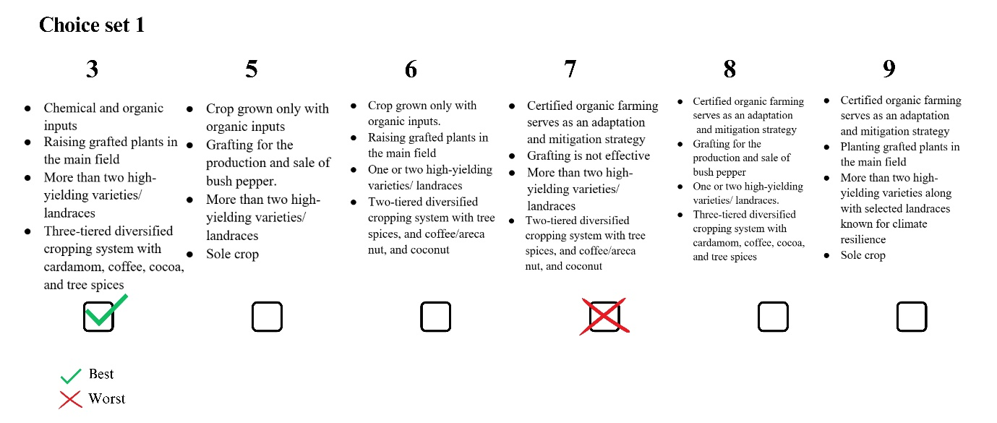

Figure 2 A model choice set consisting of profiles 3,5,6,7,8 and 9

2.6 Statistical Analysis

2.6.1 Counting method

Consider that there are *P* profiles and *N* respondents. The counting approach calculates Best Worst Scale scores (BWS scores) based on the number ofj times (*i*.*e*., the frequency or count) profile *i* is selected as the best ($B_{ij}$.) or worst ($W_{ij}$.) profile among all the questions for *j*threspondent, where *i* = 1,2,…, *P* and *j*=1,2,…, *N*. An aggregated Best Worst score of *i*thprofile (${BW}_{i}$) and mean standardizedBest Worst score ($mean {std. BW}_{i}$) is calculated for each profile using the equations (1) and (2) (Finn and Louviere 1992; Lee, Soutar, and Louviere 2007a; Cohen 2009; Mueller, Francis, and Lockshin 2009).The frequency with which profile *i* is selected as the bestacross all questions for *N* respondents is defined as $B_{i}$ . Similarly, the frequency with which profile *i* is selected as the worst item is defined as $W_{i}$ . Where $B_{i}=\sum_{j=1}^{N}{B_{ij}},W_{i}=\sum_{j=1}^{N}{W_{ij}}$. *r* is the frequency with which profile *i*appears across all choice sets.Asquare root of the ratio of ${ B}_{i}$ and $W_{i}$ for the *it*h profile ($sqrt.{BW}_{i}$)and standardized scoreis calculated using equation (3) and (4).

$${BW}_{i}=B_{i}-W_{i}$$

**(1)**

$${mean std. BW}_{i}=\frac{B_{i}-W_{i}}{Nr}$$

**(2)**

$$sqrt.{BW}_{i}=\sqrt{\frac{B_{i}}{W_{i}}}$$

**(3)**

$$std.sqrt.{BW}_{i}=\frac{sqrt.{BW}_{i}}{max.sqrt.{BW}_{i}}$$

**(4)**

Where $max.sqrt.{BW}_{i}$  is the maximum value of $sqrt.{BW}_{i}$ .Profiles with higher ${BW}_{i}$ scores and $sqrt.{BW}_{i}$, accompanied by lower standard deviations ${std. BW}_{i}$ and $std.sqrt.{BW}_{i}$, exhibit more consistent and widely accepted preferences among respondents. Conversely, profiles with higher standard deviations may indicate greater variability in respondents' perceptions, suggesting diverse or polarized opinions regarding the desirability of those profiles. Hence, while high scores indicate favourable profiles, evaluating their standard deviations offers insights into the consensus or variability in respondents' preferences, aiding in the interpretation of the overall preference landscape. This suggests that profiles with high scores are perceived as particularly favourable or effective in the context of the climate resilience strategies under consideration.

2.6.2 Modelling Approach

In addition to analysing responses at the profile level, it is imperative to gain clarity at the attribute level as well. This involves identifying the most preferred attribute levels to ensure a comprehensive understanding of respondents' preferences. By examining preferences at the attribute level, we can identify the specific attributes and attribute levels that are most favoured by respondents. This process enables us to consider any potential combinations of attributes that may not have been explicitly addressed in the study. Understanding the preferred attribute levels allows for the exploration of alternative combinations that align with respondents' preferences. The modelling approach employs discrete choice models to analyse the responses, with the dataset formatted according to the selected model specifications. Specifically, a maximum difference (maxdiff) model, as outlined by Lancsar*et al*. (2013) and Marley and Pihlens (2012), is utilized for the analysis. This model assumes that respondents derive utility from each profile within a choice set and select the best and worst profiles based on their subjective utilities. In the maxdiff model, respondents are assumed to select profile *i*as the best and profile *j* (where *i* ≠ *j*) as the worst because the difference in utility between these two profiles represents the greatest utility difference among all possible pairings. The number of utility differences in a pair is equal to the number of possible pairs in which profile *i* is selected as the best and profile *j* is selected as the worst from *P* profiles, calculated as *P* × (*P*-1).

The probability of selecting profiles from a choice set S for each model can be expressed using the conditional logit model. Under assumptions such as a choice set consists of nine profiles S={1,2,3,…,9} respondent *k* selected Profile *i* as the first best (FB), Profile j as the first worst (FW). Where *i* ≠ *j* = 1,2,…, *P* and *k* =1,2,…, *N*. then the probability can be expressed using the equation 5

$$\operatorname{Pr}\left(FB=,WB=\right)=\frac{exp⁡(v_{i}-v_{j})}{\sum_{i,j∈S,i≠j}{exp⁡(v_{i}-v_{j})}}$$

**h(5)**

where $v_{i}=x_{i}^{'}β$ ; $x_{i}^{'}$  is a vector of attribute-level variables for profile *i*; and $β$  is a vector of the coefficients to be estimated.

3. Result and discussion

Best Worst scores were calculated using equations 1, 2, 3, and 4 and the results are presented in Table 5 below. The profiles were ranked accordingly based on themean ${BW}_{i}$, mean ${std. BW}_{i}$ and $sqrt.{BW}_{i}$ values.

|  |  |  |  |  |  |  |  |  |
| --- | --- | --- | --- | --- | --- | --- | --- | --- |
| Profile | $$B_{i}$$ | $$W_{i}$$ | $${BW}_{i}$$ | Rank | Mean ${BW}_{i}$ | Mean $${std. BW}_{i}$$ | $$sqrt.{BW}_{i}$$ | $$std.sqrt.{BW}_{i}$$ |
| 1 | 52 | 415 | -363 | 9 | -2.420 | -0.303 | 0.354 | 0.104 |
| 2 | 133 | 202 | -69 | 6 | -0.460 | -0.058 | 0.811 | 0.239 |
| 3 | 167 | 258 | -91 | 7 | -0.607 | -0.076 | 0.805 | 0.237 |
| 4 | 379 | 33 | 346 | 1 | 2.307 | 0.288 | 3.389 | 1.000 |
| 5 | 133 | 192 | -59 | 5 | -0.393 | -0.049 | 0.832 | 0.246 |
| 6 | 78 | 178 | -100 | 8 | -0.667 | -0.083 | 0.662 | 0.195 |
| 7 | 255 | 169 | 86 | 4 | 0.573 | 0.072 | 1.228 | 0.362 |
| 8 | 262 | 143 | 119 | 3 | 0.793 | 0.099 | 1.354 | 0.399 |
| 9 | 333 | 202 | 131 | 2 | 0.873 | 0.109 | 1.284 | 0.379 |

Table 5 Best worst score calculated based on counting method for nine profiles

The scatter plot in Figure 3, depicting the mean BWS score (mean ${BW}_{i}$) against the standard deviation of respondents' preferences, offers insights into the variability of preferences for different climate resilience strategies represented by profiles. Profile 4 notably distinguishes itself with a substantially high mean BWS score of 2.307 and a comparatively low standard deviation. This suggests that Profile 4 embodies a climate resilience strategy that resonates strongly with respondents, eliciting consistently positive evaluations across the board. In contrast, the majority of other profiles received negative or near-zero scores, indicating greater variability and ambiguity in respondents' perceptions regarding their effectiveness in enhancing climate resilience. Therefore, Profile 4 emerges as a standout choice, signifying a robust and widely accepted climate resilience strategy among respondents, characterized by its effectiveness and consensus in addressing climate-related challenges.

Despite increases weighted average maintenance cost as estimated during the study (127% higher than conventional methods of using organic and chemical inputs farmers prefer organic farming as they consider it as a long term decision for climate adaptation. Farmers view organic farming as a significant long-term investment due to its promotion of autonomy, economic efficiency, and resilience factors in farm management(Bouttes et al., 2019). (Perrin et al., 2020,) The regions surveyed have a robust market for organic products, particularly in agro-tourism. Peer made Development Society in Idukki district has provided technical assistance and facilitated entry into international organic markets since 1997.(Parvathi & Waibel, 2016)

**Table 1: Average maintenance cost in conventional and organic method of cultivation (Rs/acre)**

|  |  |  |  |  |
| --- | --- | --- | --- | --- |
| Particulars | Yield increasing phase | Yield stabilising phase | Yield declining phase | Mean (weighted) |
| Conventional | 73034 | 81340 | 60679 | 70311 |
| Organic | 90099 | 91801 | 75811 | 89818 |

The black pepper crop in Kerala faces challenges from diseases, pests, and climate variability. Foot rot disease, especially prevalent during the southwest monsoon season, causes significant crop losses (Anju et al., 2023).Farmers who have high levels of aspirations to continue farming are seeking ways to increase resistance to the disease, with some turning to grafted plants on the rootstock *Piper colubrinum*the main field. Higher aspirations in agricultural and rural development drive technology adoption and input choice, leading to increased agricultural productivity through enhanced investment in productivity-enhancing technologies and management practices(Mausch et al., 2018)(Genicot & Ray, 2020)

However, a limited number of studies indicate that grafted plants have limitations, including a lifespan of only nine to ten years and a lower number of fruit-bearing spikes. So lack of scientific validation makes this practice a less preferred adaptation practice among the majority of farmers. Additionally, the need for regular irrigation poses challenges, particularly for smallholders with limited resources (Hema et al., 2007).

Farmers observe that “grafted plants exhibit vigorous growth, rapid establishment, tolerance to flood, and resistance to foot rot in field conditions”. In unfamiliar situations, tacit knowledge influences behavior, assisting decision-making within the constraints of bounded rationality by relying on observed actions rather than explicit reasoning.

Farmers skilled in grafting are considering grafting on Piper colubrinum for bush pepper production as an alternative income boost. As skill sets possessed are varied, that itself influences decision making behaviour.

Farmers have the capacity to select from a pool of crop varieties that meet their preferences and growing conditions (Asfaw et al., 2011). In organic farming, farmers prioritize the use of locally adaptable, climate-resilient land races alongside improved varieties. Recent studies in black pepper cultivation have shown the dominance of two varieties: Karimunda, an improved landrace, and Panniyur 1, known for its high yield across Kerala. However, surveys have revealed the presence of diverse landraces such as Jeerakamundi, Vellanamban,Kottanadan, Kumbikul and Perumkodi (to name a few ) , which farmers prefer and maintain due to their resilience to varying climatic conditions. These land races contribute to the diversity of genes and species in an ecosystem which h influences ecosystem resilence(Loreau et al., 2002; Chee, 2004)

Black pepper cultivation in India occurs within traditional agroforestry landscapes, where native canopy cover is maintained, and it is commonly intercropped with coffee, Arecanut, Coconut, and tree spices like Clove, Nutmeg, Allspice, and Cinnamon.

In the study areas of Idukki and to some extent in Wayanad district, traditional pepper cultivation has transitioned into cardamom-based three-tier diversified systems. This conversion is gradual due to challenges such as senile or foot rot-affected pepper vines, which struggle to thrive when intercropped with cardamom. The intense shade created by the ground cover of cardamom hampers the growth of these pepper vines, contributing to the gradual nature of the shift.The shade requirement of cardamom is more than that of coffee and it affects the sunlight requirement for black pepper. The pace of this transition has accelerated recently due to a significant increase in cardamom prices.

Coffee provides natural shade and mulching, particularly beneficial in the inter-row spaces, which helps prevent soil parching, a phenomenon observed following floods in 2018 and 2019. Previous studies have demonstrated that the coffee-black pepper agroforestry system typically includes shade trees ranging from 77 to 142 per acre, with a Shannon’s index measuring 2.37, slightly lower than that of natural forests at 2.50 (CAFNET, 2011; Chethana, Nagaraj, Chengappa, & Gracy, 2010).Discussions with experts on best agronomic practices for black pepper, coupled with findings from previous studies like Chengappa et al. (2017), emphasize the importance of integrating coffee, cocoa, and tree spices into pepper-diversified systems to ensure sustainable production. Despite this consensus, the preference revealed in the choice experiment for three-tier diversified systems incorporating cardamom implies a strategic, long-term adaptation to mitigate the effects of price volatility in black pepper and cardamom markets.The crop combination of black pepper, areca nut, and coconut constitutes the most widely adopted diversified three-tier system in lowlands where cardamom and coffee are not cultivated. Additionally, tree spices and cocoa are also cultivated within such three-tier systems.

During our study, we observed a greater diversity in standards for black pepper cultivation, particularly with the incorporation of multipurpose trees such as *Hevea brazilensis, Artocarpus heterophyllus, Mangifera indica, and timber species like Tectona grandis, Artocarpus hirsutus, Swietenia mahagoni*, among others. This contrasts with the traditional standards which typically include species such as *Erythrina indica, Macaranga peltata, Erythrena variegate, Gliricidiasepium, Pajanellareedi, Leucaena leucocephala, Grevillea robusta, Ailanthus triphysa and Oroxylum indicum.*

Such agroforestry systems also contribute to climate change mitigation. However, we did not include them in our choice analysis because further research is required to define attribute levels for this aspect.

In addition to Profile 4, Profiles 7, 8, and 9 also demonstrated positive BWS scores indicating their effectiveness as climate resilience techniques. These profiles are grouped closely together in the plot, following Profile 4, with BWS values of 0.573, 0.793, and 0.873, respectively. This clustering suggests that these profiles share similarities in their perceived efficacy and appeal among respondents. While Profile 4 stands out as the most favoured option with the highest BWS score, Profiles 7, 8, and 9 follow behind, representing viable and promising climate resilience techniques. Profile 9 has high standard deviation indicating a varied response among the respondents. Together, these profiles contribute to a repertoire of strategies that respondents view positively in terms of their potential to enhance resilience to climate-related challenges. Profile 1 is the least preferred as it does not offer any potential resilience strategy to farmers.Figure 4 displays the rank order arrangement of the profiles along with their ${mean std. BW}_{i}$ scores, effectively summarizing the aforementioned findings. From figure 5 it is clear that profile 4 has less negative BW scores and it is noteworthy that Profile 7, 8, 9 has also achieved a maximum BW score value 8 for several respondents but also gained considerable high negative values indicative of mixed responses.

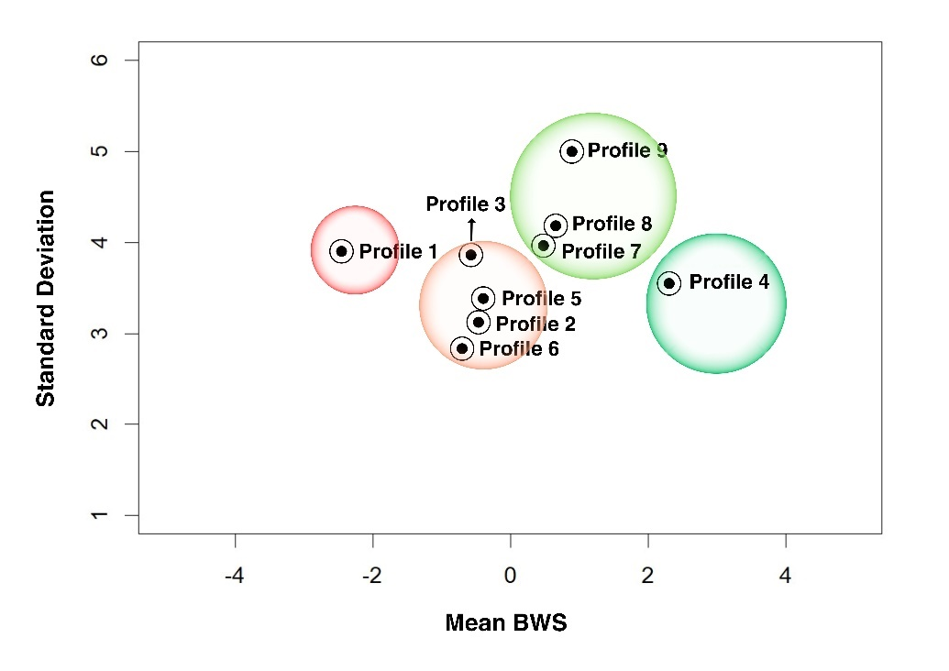

Figure 3 Scatterplot based on mean ${BW}_{i}$ and its Standard deviation

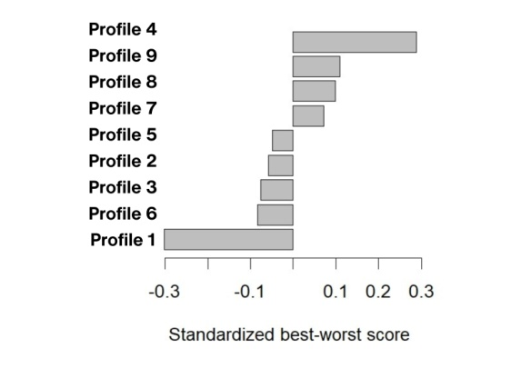

Figure 4 Rank order arrangement of profiles along with ${meanstd. BW}_{i}$

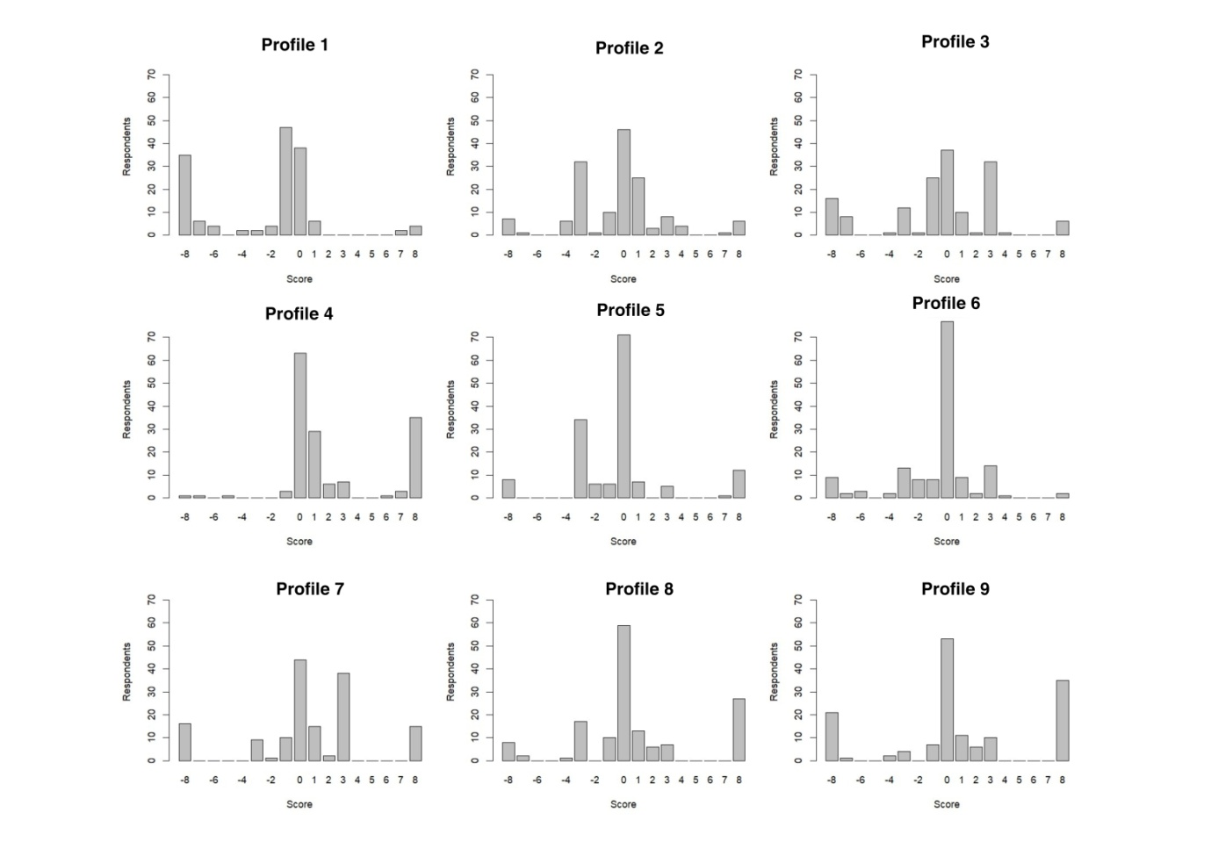

Figure 5Frequency of Individual Best Worst (BW) Scores of Respondents

A utility function is developed for the purpose of fitting a conditional logistic model to the responses on the basis of the maxdiff model to study the attribute level preference. While constructing utility function the attribute levels(A1) A combination of chemical and organic methods proves more effective for adapting to climate change, (B2) Production and sale of bush pepper plants having ornamental and culinary value grafted on *Piper colubrinum* for home gardens.(C1) One or two high-yielding varieties/ landraces,(D1) Sole cropin corresponding profileare considered as a reference for dummy variables. These attribute levels were considered as reference levels because farm products derived from a hybrid of chemical and organic management lack the market attribute specificity in asset quality and do not promote long-term climate adaptation. Farmers gave a varied response towards grafting technology in black pepper attributed to its perennial nature, prompts this study to explore the spectrum of adoption, ranging from complete rejection to full integration. The analysis of secondary data on the adoption of black pepper varieties in Kerala revealed the predominance of Karimunda and Panniyur 1 across all pepper-growing districts. However, considering the importance of genetic diversity beyond these two varieties, further exploration was deemed necessary. Hence, C1 was chosen as the reference level. Given that sole cropping is the least favoured cropping system for climate-resilient farming, this study aims to explore variations beyond this level in the choice analysis.

B2, C1, D1) as reference points, the utility function contrasts the preference for other attribute levels against these references. This comparison enables the identification of how respondents' preferences deviate from or align with the chosen reference levels.

A1 – Farm products derived from a hybrid of chemical and organic management lack the market attribute specificity in asset quality and do not promote long-term climate adaptation.

B2 - Farmers gave a varied response towards grafting technology in black pepper

attributed to its perennial nature, prompts this study to explore the spectrum of adoption, ranging from complete rejection to full integration, using B2 as the benchmark reference

C1 - D1– Given that sole cropping is the least favored cropping system for climate-resilient farming, this study aims to explore variations beyond this level in the choice analysis.

Accordingly, the systematic component of a utility function for the nine profiles (*i* = 1,2,…, 9) is as follows

$$v_{i}=β_{1}A_{2}+β_{2}A_{3}+β_{3}B_{1}+β_{4}B_{3}+β_{5}C_{2}+β_{6}C_{3}+β_{7}D_{2}+β_{8}D_{3}$$

Where $A_{2}$, $A_{3}$, $B_{1}$, $B_{3}$, $C_{2}$, $C_{3}$, $D_{2}$, $D_{3}$ are dummy variable taking the value of 1 if *i*th profile has the attribute level A2, A3, B1, B3, C2, C3, D2, D3 respectively, 0 otherwise;. $β$ s are coefficients (parameters) for these variables. Conditional logistic model is fitted using *clogit()* function of*survival* package(Therneau,2023) inR (R Core Team, 2021).

|  |  |  |  |  |
| --- | --- | --- | --- | --- |
| Attribute level | $$β$$ | Odds ratio | se($β$) | Pr(>|z|) |
|  | 0.793 | 2.210 | 0.078 | 0.000** |
| $$A_{3}$$ | 0.148 | 1.160 | 0.082 | 0.069ns |
|  | -0.654 | 0.520 | 0.079 | 0.000** |
| $$B_{3}$$ | -0.407 | 0.666 | 0.08 | 0.000** |
| $$C_{2}$$ | 1.051 | 2.86 | 0.085 | 0.000** |
| $$C_{3}$$ | 0.422 | 1.524 | 0.081 | 0.000** |
| $$D_{2}$$ | 0.414 | 1.513 | 0.081 | 0.000** |
| $$D_{3}$$ | 0.077 | 1.080 | 0.078 | 0.329ns |

Table 6: Conditional Logistic Regression Results for Attribute Level Preferences

The results of the conditional logistic regression analysispresented in Table 6 provide insightful implications regarding the influence of different attribute levels on respondents' preferences for climate resilience strategies. The highly significant coefficient ($β_{1}$) of 0.793 associated with attribute level A2, representing the exclusive use of organic inputs in crop cultivation, indicates a substantial positive impact on preference. This suggests that respondents are 2.210 times more likely to favour attribute level A2 compared to the reference level, emphasizing the perceived effectiveness of organic farming practices in adapting to and mitigating climate change-related challenges.

Conversely, attribute levels B1 and B3 exhibit significant negative effects on preference, implying that respondents are less inclined to prefer these attribute levels relative to the reference level. Farmers prefer the reference level as the grafting technique proves effective for propagating bush pepper in home gardens where irrigation costs are not prohibitive.Additionally, attribute level C2 stands out with a highly significant odds ratio of 2.86, indicating a strong preference among respondents. Attribute level C3 also demonstrates a positive effect on preference, further highlighting the significance of landrace diversity in respondents' decision-making processes.Moreover, both attribute levels D2 and D3 display significant coefficients with odds ratios greater than 1, indicating an increased likelihood of preference compared to the reference level.

References

Louviere, J. J., T. N. Flynn, and A. A. J. Marley. 2015. Best–Worst Scaling: Theory, Methods and Applications. Cambridge, UK: Cambridge University Press.

R Core Team (2021). R: A language and environment for statistical computing. R Foundation for Statistical Computing, Vienna, Austria. <https://www.R-project.org/>.

Grömping U (2018). “*R Package DoE.base for Factorial Experiments*.” Journal of Statistical Software, 85(5), 1–41. doi:10.18637/jss.v085.i05.

Sailer MO (2022). _crossdes:Construction of CrossoverDesigns_. R package version 1.1-2. <https://CRAN.R-project.org/package=crossdes>

Finn, A., and J. J. Louviere. 1992. “Determining the Appropriate Response to Evidence of Public Concern: The Case of Food Safety.” Journal of Public Policy & Marketing, 12–25. <https://doi.org/10.1177/074391569201100202>.

Lee, J. A., G. N. Soutar, and J. Louviere. 2007a. “Measuring Values Using Best-Worst Scaling: The Lov Example.” Psychology & Marketing 24 (12): 1043–58. <https://doi.org/10.1002/mar.20197>.

Cohen, E. 2009. “Applying Best-Worst Scaling to Wine Marketing.” International Journal of Wine Business Research 21 (1): 8–23. <https://doi.org/10.1108/17511060910948008>.

Mueller, S., I. L. Francis, and L. Lockshin. 2009. “Comparison of Best–Worst and Hedonic Scaling for the Measurement of Consumer Wine Preferences.” Australian Journal of Grape and Wine Research 15 (3): 205–15. <https://doi.org/10.1111/j.1755-0238.2009.00049.x>.

Lancsar, E., J. Louviere, C. Donaldson, G. Currie, and L. Burgess. 2013. “Best Worst Discrete Choice Experiments in Health: Methods and an Application.” Social Science & Medicine 79: 74–82. <https://doi.org/10.1016/j.socscimed.2012.10.007>.

Marley, A. A. J., and D. Pihlens. 2012. “Models of Best-Worst Choice and Ranking Among Multiattribute Options (Profiles).” Journal of Mathematical Psychology 56: 24–34. <https://doi.org/10.1016/j.jmp.2011.09.001>.

Therneau T, 2023. A Package for Survival Analysis in R_. R package version 3.5-7, https://CRAN.R-project.org/package=survival.